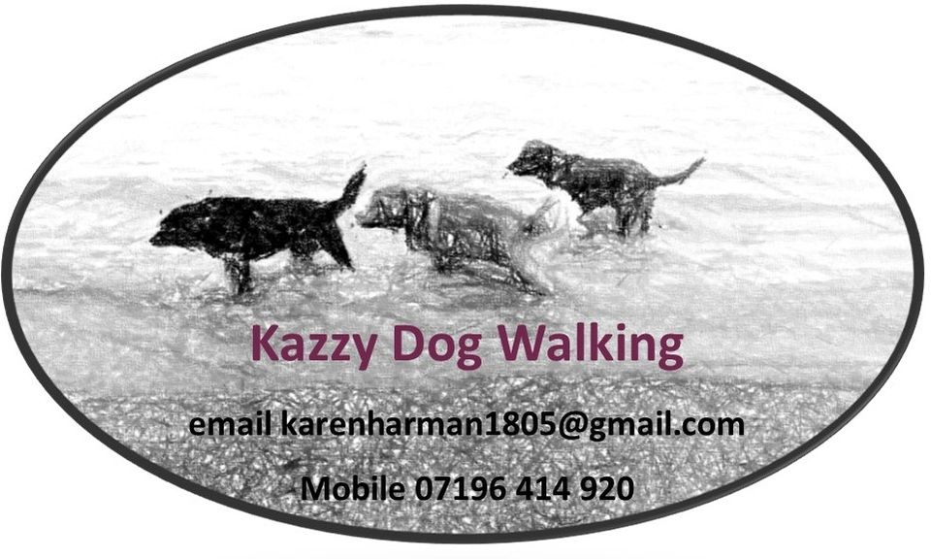

I am an experienced dog walker and owner with a Pet Sitting and Dog Walking diploma.
I have also completed a course in Pet First Aid.
I can also come to your home to feed your pet, check on them, and exercise them.
I can pick your dog up and drop them off.
I can walk your dog with and without the company of other dogs.
I am insured.
Terms and conditions are available on request.
I have a clear DBS available to view on request.
Recommendations
15/10/2024
Kelly Roberts
Karen is very friendly and approachable; she was able to meet Marley quickly. He seems happy which is most important.
15/02/2024
Kirsty Fletcher
Kazzy dog walking has been great. My dog gets picked up and taken for a good walk each day while I’m at work and I know she’s in good hands. I would recommend it.
15/02/2024
Fran Harman
Karen walks our dog with her dog, and he loves it. Always sleeps well after a good run with her own dog 🐶
DBS

Date of issue
09/08/2024

Certificate number
001193834188

Applicant details
First name: KAREN
Last name: HARMAN
Date of birth: 18/05/1961
Current Address:
14 BRENDON ROAD
WORTHING
BN13 2PT
United Kingdom

Police records check
This basic DBS check revealed no information.

Paper certificate
The online result alone is evidence of a basic DBS check, but we'll also send out a paper certificate.

For any Questions call 01284 736 874 or email us on info@petbusinessinsurance.co.uk

CONFIRMATION OF COVER
Thank you for choosing Pet Business Insurance.
Please check the information in this email carefully to ensure that it reflects your instructions and requirements with regards to the extent of the cover provided.
Summary of Cover and Terms of Business documents are attached. Your Insurance Documents will be emailed to you within the next 72 hours. If you don’t received your policy documents then please check your Spam or Junk folder in case they are in there.
If you have any queries please do not hesitate to contact us on +44 01284 736 874 (M-F 9am5pm) or email info@petbusinessinsurance.co.uk.

Give your customers confidence in your professional service, show them you have the best insurance cover from Pet Business Insurance.
If you have a website and would like to place one of our "Covered by" badges on it please click here.

Your COVER
You chose to pay for your cover monthly.
Cover Reference: 71kJxU3QjA
Total Premium: £124.50
Total amount to be paid is £136.95 this amount includes a finance fee of £12.45. The total amount will be taken from your bank in 11 equal payments of £12.45. Your policy will start on: 26/09/2024 and run for 12 months.

Your Cover Includes
Dog Walking (Maximum 6 Dogs to be walked at any one time):
£1,000,000 Public Liability
£75,000 Accidents and Injuries to Animals (£25,000 per incidence)
£10,000 Loss of Keys
£1,000 Loss of Money
£1,000 Equipment Cover
£2,500 Travel Costs
£10,000 Loss of Licence Cover

Selected Optional Covers
Animal Illness Cover for 4 animals

Cover Details
Primary Services: | Dog Walking (Maximum 6 Dogs to be walked at any one time)
What level of Public Liability cover do you require? | £1,000,000
Where are you based: | England, Scotland or Wales
Turnover (£): | £3,000
Do you require Employers Liability Cover? | No
Do you require Legal Expenses Cover? | No
When would you like your policy to start: | Today
Voucher or Coupon Code:

Optional Covers
How many people require Personal Accident Cover? | 0
How many employees require Employee Accident Cover? | none
Do you require Professional Indemnity Cover? | No
Do you require Personal Possession Cover? | No
How much additional Equipment Cover do you require? | £0
How many animals do you need Animal Illness Cover for? | 4
Cats/other small domestic Pets: | 0
Do you require Glass Cover? | No
Do you require Business Interruption Cover (ICOW)? | No
Do you require Additional Loss of Money Cover? | No
Would you like to increase your Loss of Licence Cover to £50,000? | No
Do you require Deterioration of Chilled Stock Cover? | No

Your Details
Title: | Mrs
First Name: | KAREN
Surname: | HARMAN
Date of Birth: | 18/05/1961
Telephone Number: | 07496 4149 20
Email: | karenharman1805@gmail.com
Confirm Email: | karenharman1805@gmail.com
10 Locations found: | 14 Brendon Road, Worthing, BN13 2PT
Address: | 14 Brendon Road
 | Worthing
 | West Sussex
Postcode: | BN13 2PT
Company Name: | Kazzy Dog Walking
Names of other directors or partners:

Declarations
I/We declare that I/we or any of the officers, business partners or directors have NOT been convicted or charged with (but not yet tried) a criminal offence other than a minor motoring conviction and have NOT been declared bankrupt or insolvent or had a CCJ. | Agree
I/We declare that I/we have had NO losses suffered, whether or not claimed for, in respect of any of the risks for which cover is required. | Agree
I/We declare that I/we have NOT had any insurer in respect to which this policy refers declined to insure you, cancelled or refused to renew your insurance or imposed any special terms. | Agree
Have you read and downloaded the Demands and Needs statement. | Yes
Have you read, downloaded, understood and agree with the Statement of Facts. | Yes
Do you understand that, should you proceed to purchase cover, Pet Business Insurance and any associated affiliate or discount programme facilitator will receive your details for the purposes of providing you insurance and for the purposes of affiliate tracking only and your details will NOT be used for marketing purposes. | Yes

Please do not reply to this email as it comes from an automated mailbox that cannot accept replies.
Pet Business Insurance is Authorised and Regulated by the Financial Conduct Authority.

Tel: 01284 736 874 | Copyright © Pet Business Insurance

This communication and any attachments are confidential and may be legally privileged. It is intended only for the stated addressee(s). If you have received it in error please notify us immediately or email info@petbusinessinsurance.co.uk and note that any storage, use or disclosure is strictly prohibited and may be unlawful. Whilst we check the communications we send for known viruses, we accept no responsibility for any loss or damage caused to your systems by this communication. Those communicating with us by electronic mail will be deemed to have accepted the risks associated with interception, amendment, loss and late or incomplete delivery. They will also be deemed to have consented to our intercepting and monitoring such communications.

